DATA CHALLENGES FOR E-MOBILITY

Under the guidance of,

Dr . Joseph Michael Jerard V

PROFESSOR

School of CSE

Presidency University

|  |  |  |
| --- | --- | --- |
| G Akshay Kumar  *School of Engineering*  *Presidency University*  Bangalore, India  ak2773266@gmail.com | P Mohammad Fayaz  *School of Engineering*  *Presidency University*  Bangalore, India mohammadfayaz7602@gmail.com | M Lokesh Yadav  *School of Engineering*  *Presidency University*  Bangalore, India ro@gmail.com |

***Abstract*** — **The project title "Data Challenges for E-Mobility" focuses on creating a streamlined system to manage and improve the efficiency of electric vehicle (EV) infrastructure. The system comprises three modules: Admin, User, and EV Centre. The admin module allows administrators to log in, add EV charging centers, and address user complaints. Users can register, log in, and view nearby EV charging centers with location and calling options, ensuring convenience and accessibility. EV Centre operators can log in to view and resolve complaints, enhancing service reliability. This project addresses key data management and operational challenges in the e-mobility sector.**

***Keywords—E-Mobility, Electric Vehicle Infrastructure, Complaint Resolution, Sustainable Mobility, Data Management***

I. INTRODUCTION

Electric mobility is transforming global transportation by reducing carbon emissions and promoting sustainability. However, challenges in managing EV charging infrastructure, such as inefficient complaint handling and accessibility issues, hinder widespread adoption. This paper proposes a platform to streamline operations, ensuring seamless interaction among users, administrators, and EV centers. The solution aims to improve user experience and operational reliability while promoting sustainable mobility.

The transition to electric mobility is a vital step toward mitigating the adverse effects of climate change and reducing dependency on fossil fuels. Governments worldwide are introducing policies and incentives to accelerate EV adoption, prioritizing developing a reliable charging infrastructure. However, the lack of an integrated system addressing user needs, operational challenges, and data management inefficiencies creates barriers to adoption.

Efficient coordination among stakeholders—users, administrators, and EV centre operators—is essential for creating a cohesive and user-friendly charging network. This paper identifies these gaps and proposes an innovative solution tailored to the requirements of the evolving e-mobility ecosystem.

1. *Illustration*

The proposed platform enhances the usability of existing EV infrastructure and introduces a scalable approach to accommodate future advancements in e-mobility technology. By focusing on real-time complaint resolution, optimized charging station management, and improved accessibility, the system contributes to a sustainable and user-centric transportation model. Through this approach, the study highlights the critical role of technological innovation in addressing real-world challenges and fostering a more sustainable future. The electric vehicle sector faces significant challenges in managing and optimizing EV charging infrastructure. There is a lack of effective systems for connecting users with nearby charging stations, handling complaints, and ensuring operational reliability. The absence of a streamlined communication platform between users, administrators, and charging centre operators results in inefficiencies, poor user experience, and delayed resolution of issues. The system will facilitate seamless interaction between EV users, administrators, and charging centre operators to improve service delivery, resolve complaints, and ensure accessibility to EV charging stations. The project aims to develop a comprehensive platform that enhances the management and efficiency of electric vehicle (EV) infrastructure by integrating three core modules: Admin, User, and EV Centre As e-mobility adoption grows, addressing these gaps becomes critical to supporting sustainable mobility and enhancing the overall EV ecosystem.

## II. EXISTING METHOD

1. *Advantages*

The platform offers significant advantages for the e-mobility sector. By enabling seamless integration between users, administrators, and EV centre operators, it ensures improved accessibility and operational efficiency. Real-time complaint tracking and resolution enhance user satisfaction, while centralized data management provides administrators with valuable insights into system performance and usage trends.

1. *Limitations*

The initial implementation may involve high costs, and reliance on stable internet connectivity could pose challenges in areas with limited network infrastructure. User adoption might require significant outreach and training to transition from traditional systems to the new platform.

III. LITERATURE REVIEW TABLE 1

|  |  |  |  |  |
| --- | --- | --- | --- | --- |
| **No** | **Paper Title** | **Method** | **Advantages** | **Limitations** |
| 1 | Postcolonial pandemic publics: examining social media health promotion in India during the COVID-19 crisis  [5]. | Quantitative data analysis and  qualitative interview methods.  Offline data  collection and  qualitative analysis. | Easy data collections.  Best suits for  qualitative analysis. | Only few get access to attend the interview.  Lack of  Knowledge about the data collections |
| 2 | Young adults’ use of different social media platforms for health information:  Insights from web based  conversations.[6] | Web-based conversation  methodology  to collect  data | Offer health related queries based on user query. | No prior information is given to the user before the query. |
| 3 | Social Media and Health Care (Part II): Narrative  Review of Social Media Use by  Patients [7]. | Between  March and  June 2020, a review of the literature was conducted on  PubMed,  Google  Scholar, and  Web of  Science | Social media can be used by the public and patients to improve their health and knowledge. | Diligence  must be practiced to assess the credibility of the information  obtained and its source. |
| 4 | Benefits,  Challenges and Social Impact of  Health Care  Providers’  Adoption of Social Media [8]. | In-depth interviews were conducted | 1. Enhanced communication between health care   professionals  and their  patients,   1. community support, (iii) enabled e-learning,   (iv) enhanced professional network | (i)Inefficiency   1. privacy   concerns,   1. poor quality of   information,   1. lack of   trust   1. blurred   professional boundary |
| 5 | Social media  influencer marketing [9]. | The  researcher  chose to  approach  answers to  research  problem with  qualitative approach,  which is an  unstructured, explanatory research methodology | Self disclosure has a positive effect on  influencer’s  credibility  when self disclosure is perceived to be appropriate | Uncovering deeper insights about underlying motives. Attributing the responses directly to the responder. Having free exchanges of information. |

Fig. 1. Literature Review

## IV. PROPOSED METHOD

1. *Definition*

Hundreds of online web applications, mainly social media apps, provide content to entertain people with everything happening around the world. But this application we are about to make only allows users to get information, especially content related to health and other physical activities. We will also include all the worldwide health feeds and other related content. Include features such as buying all the health-related products, adding badges, and being visible to all the different end-users using these applications, Gamify the user experience, and many more.

1. *Details of new Method*
   1. *User registration:* Allows users to create an account and log in to the platform to access personalized health content.
   2. *Content categorization:* Enable users to search for health content based on categories such as nutrition, fitness, mental health, etc.
   3. *Analytics:* Provides Analytics for influencers and

users to track engagement, audience demographics, and content performance.

* 1. *Personalization:* Provides personalized health recommendations and content based on user preferences and past interactions.
  2. Social sharing: Allows users to share content on social media platforms and connect with other users with similar health interests.

## V. OBJECTIVES

1. *Performance*

The Applications should provide a seamless and satisfying user experience without any lag or delay in the functionality. A poorly performing application, on the other hand, can frustrate users, negatively impact retention and user satisfaction, and result in bad reviews.

1. *Scalability*

To ensure scalability, developers must design and build their applications with scalability in mind. This may involve using technologies and architectures that can scale horizontally (adding more servers) or vertically (adding more resources to existing servers) and implementing strategies like load balancing, caching, and database sharing to distribute workloads and improve performance.

1. *Mobile Compatibility*

It can be achieved through various techniques, such as responsive web design, which allows the web application to automatically adjust its layout and content based on the screen size and orientation of the device. Other techniques may involve: Optimizing images and other media for mobile devices.Using touch-friendly controls and navigation.

Ensuring the web application is accessible and usable on various mobile devices and platforms.

## VI. METHODOLOGY

1. *Prerequisite*
   * Identify the target audience
   * Conduct market research
   * Define the apps feature
   * Develop a wire-frame
   * Design & develop the app
   * Test the app
   * Launch the app
   * Monitor and improve
2. *Architecture*

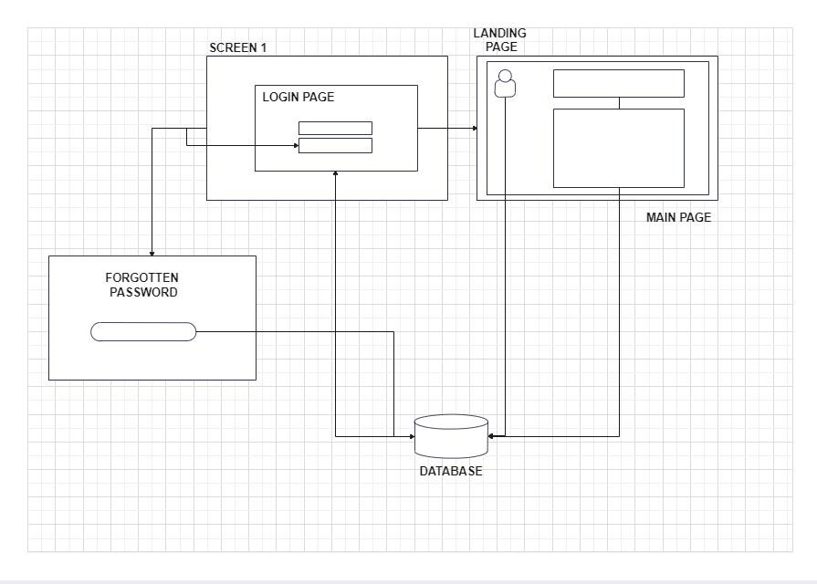

Fig. 2. Architecture of the landing home web page [12].

1. *Experimental Details*

## TABLE 2

|  |  |  |
| --- | --- | --- |
| **Hardware Details** | **Software Details** | |
| ***Front-end*** | ***Back-end*** |
| RAM ( > 8 GB ) | HTML | Node.js |
| Graphic Card (> 4 GB) | CSS | MongoDB |
| Java Script | REST API |
| React.js |

Fig .3. Hardware and software details

*D. Outcome*

The project's outcome will depend on the specific goals and objectives. Generally, the outcome of a project like this could include:

* Increased awareness of personal health topics.
* Increased engagement with health-related content.
* Increased engagement with health professionals.

The project could also lead to increased health-related behaviour changes, such as improved diet and exercise habits and mental health.

## VII. CONCLUSION

In conclusion, social media has become essential for healthy development, providing a platform for health professionals to share information, connect with us, and promote health initiatives. It has also enabled individuals to access health related information and engage in health-related conversations.

REFERENCES

1. Byrne, Emer, John Kearney, and Claire MacEvilly. "The role of influencer marketing and social influencers in public health." Proceedings of the Nutrition Society 76, no. OCE3 (2017): E103.
2. Lutkenhaus, Roel O., Jeroen Jansz, and Martine PA Bouman.

"Tailoring in the digital era: Stimulating dialogues on health topics in collaboration with social media influencers." Digital health 5 (2019): 2055207618821521.

1. Kanchan S, Gaidhane A (January 13, 2023) Social Media Role and Its Impact on Public Health: A Narrative Review. Cureus 15(1): e33737. doi:10.7759/cureus.33737
2. Afful-Dadzie E, Afful-Dadzie A, Egala SB. Social media in health communication: A literature review of information quality. Health Inf Manag. 2023 Jan;52(1):3-17. doi: 10.1177/1833358321992683. Epub 2021 Apr 4. PMID: 33818176.
3. Roy, Dibyadyuti, Madhurima Das, and Aditya Deshbandhu. "Postcolonial pandemic publics: examining social media health promotion in India during the COVID-19 crisis." Health Promotion International 37, no. 2 (2022): daab076.
4. Lim, Megan SC, Annika Molenaar, Linda Brennan, Mike Reid, and Tracy McCaffrey. "Young adults’ use of different social media platforms for health information: Insights from web-based conversations." Journal of medical Internet research 24, no. 1 (2022): e23656.
5. Farsi, Deema, Hector R. Martinez-Menchaca, Mohammad Ahmed, and Nada Farsi. "Social media and health care (Part II): narrative review of social media use by patients." Journal of Medical Internet Research 24, no. 1 (2022): e30379.
6. Khan, Md Irfanuzzaman, and Jennifer Loh. "Benefits, challenges, and social impact of health care providers’ adoption of social media." Social Science Computer Review 40, no. 6 (2022): 16311647.
7. Isosuo, Heli. "Social media influencer marketing." (2016).
8. Kanchan S, Gaidhane A (January 13, 2023) Social Media Role and Its Impact on Public Health: A Narrative Review. Cureus 15(1): e33737. doi:10.7759/cureus.33737
9. Ventola, C. Lee. "Social media and health care professionals: benefits, risks, and best practices." Pharmacy and therapeutics 39, no. 7 (2014): 491.
10. https://www.edrawmax.com/online/share.html?code=189c71ccde76

11edbe8f0a951ba8b83d